STAT & SCIENTIFIC COMPUTING

ASDS5303 PROJECT FINAL REPORT

**PREDICTING A 10 YEAR RISK OF FUTURE CORONARY HEART DISEASE (CHD)**

Project By:

**SINDHURA SURAVARJHULA**

**MRUNALI SAROJ NILGIRWAR**

Under the Guidance of:

**Dr. MEI YANG**

#### Contents

1. Introduction
2. Objective
3. Dataset Description
4. Methodology
5. Analysis
6. Results
7. Discussions
8. Conclusions

#### 

#### 

#### 

#### 

#### 

#### 

#### 

#### 

#### 

#### 

#### 

#### 

#### 

#### 

#### 

#### 

#### 

#### 

#### 

#### 

#### **Introduction**

Cardiovascular diseases are among the leading causes of mortality worldwide, with coronary heart disease (CHD) being a significant contributor. Accurate risk prediction models for CHD are vital for early identification and prevention strategies. This project focuses on predicting the 10-year risk of CHD using machine learning techniques implemented in R, based on clinical and demographic data.

The dataset used in this project is derived from the Framingham Heart Study, a renowned longitudinal study that has contributed significantly to understanding cardiovascular disease risk factors.

The implications of such predictive models are far-reaching, offering a cost-effective way to enhance preventive healthcare. With the increasing prevalence of data-driven medicine, predictive analytics for CHD risk could serve as a valuable tool in routine clinical practice.

### **Objective**

The primary objective of this project is to develop a machine learning-based predictive model that can assess an individual's 10-year risk of developing CHD. This is achieved by utilizing demographic, clinical, and lifestyle factors provided in the Framingham Heart Study dataset.

**Specific Goals:**

1. **Identification of Key Predictors**: Using statistical and machine learning methods to identify the most significant variables associated with CHD.
2. **Model Building**: Develop various predictive models and compare their performance to select the most accurate and robust model.
3. **Validation and Interpretation**: Validate the selected model on unseen data to assess its generalizability and interpret the results to provide actionable insights for clinicians.

This project also explores the use of machine learning for clinical risk prediction, offering insights into how data-driven models can support medical decision-making. By focusing on accuracy, interpretability, and scalability, the model can contribute to advancing personalized healthcare solutions.

### **Dataset Description**

The dataset used in this project is a subset of the Framingham Heart Study data, which includes data collected over decades to understand cardiovascular health. The dataset contains both clinical and demographic features, which are essential for predicting CHD risk. It has a total of **4239** rows and **16** columns.

**Key Features:**

* **Demographics**: Age, sex.
* **Clinical Metrics**:
  + Total cholesterol (mg/dL): High levels indicate a risk factor for CHD.
  + HDL cholesterol (mg/dL): Often referred to as "good cholesterol."
  + Blood pressure (SBP and DBP): Hypertension is a well-known CHD risk factor.
* **Lifestyle Factors**:
  + Smoking status: Binary (smoker/non-smoker).
  + Physical activity: Categorical data indicating activity levels.
* **Medical History**:
  + Diabetes: Binary (yes/no).
  + Hypertension: Indicates if the individual is undergoing hypertension treatment.
  + Family history of CHD: Binary indicator.

The outcome variable is binary, representing whether the individual developed CHD within the 10-year follow-up period.

To identify data simpler, it is categorized as :

* + **Numerical Predictors** -
    - Age, Cigs Per Day, Tot Chol, Sys BP, Dia BP, BMI, Heart Rate, Glucose
  + **Categorical Predictors** -
    - Education
  + **Binary Predictors** -
    - Sex, Current Smoker, BP Meds, Prevalent Stroke, Prevalent Hyp, Diabetes

**Data Challenges:**

* Missing values in clinical data such as cholesterol levels and blood pressure.
* Imbalanced classes, as CHD cases are less frequent compared to non-CHD cases.
* Potential multicollinearity among clinical predictors.

### 

### **Methodology**

The methodology consists of structured steps to ensure a robust predictive model:

1. **Data Preprocessing**:
   * Missing values were handled using mean imputation for both continuous variables and categorical variables.
   * Outliers were detected and treated using interquartile ranges to prevent skewed results.
   * Normalization of continuous variables was performed to ensure models are not biased by scale differences.
2. **Exploratory Data Analysis (EDA)**:
   * Histograms and boxplots were used to examine variable distributions.
   * Scatterplots and correlation heatmaps identified relationships between predictors and CHD.
   * Smoking was found to correlate strongly with age, while diabetes showed a weak association with gender.
3. **Feature Selection**:
   * Recursive Feature Elimination (RFE): Ranked features by their predictive power.
   * LASSO regression added regularization to identify significant predictors, eliminating noise from the dataset.
4. **Model Development**:
   * Logistic regression served as a baseline model.
   * Advanced machine learning models, including Random Forest and XGBoost, handled complex, non-linear relationships.
5. **Evaluation**:
   * Metrics like AUC-ROC, F1-score, and accuracy were calculated.

### **Analysis**

### **Step 1: Collect Data**

### **Data Description:**

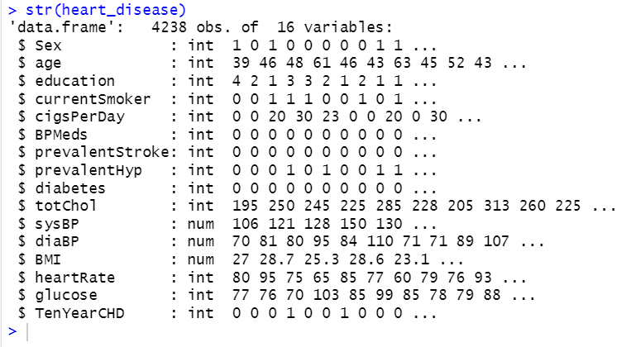

About the Data:

### Demographics information about patient

male - Gender of patient

age - Age of patient

education - Education level of patient in ordinal data

### Tobacco usage of patient

currentSmoker - information about a patient if he/she is a smoker

cigsPerDay - Amount of consumption if patient is a smoker

### 

### Health information of patient

BPMeds - If a patient is taking BP

prevalentStroke - Status of stroke occurance

prevalentHyp - Status of prevailing hyper tension

diabetes - Status of diabetes

totChol - Cholestrol level

sysBP - Blood pressure level

diaBP - Diastolic blood pressure

sysBP - Systolic blood pressure

BMI - Body mass Index

heartRate - Heart rate reading

gluscose - Glucose level

TenYearCHD - status if will suffer a risk of coronary disease in next ten years

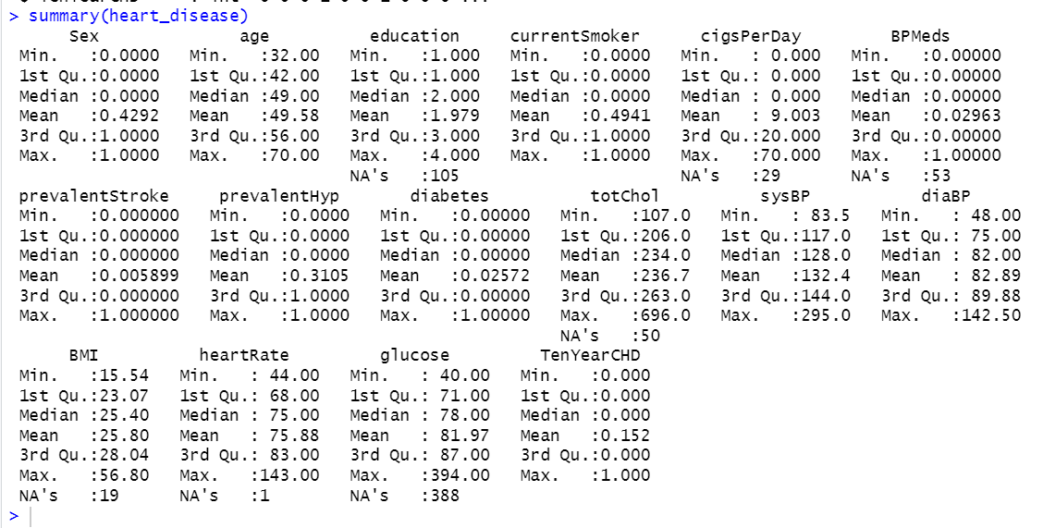

Using R, the data was imported successfully for analysis purpose. Above attached snaps are the output generated upon uploading the data and gives the description about the features.

### **Step 2: Data Cleaning**

### **Number of Null Values for each column:**

### 

For each feature, the null values were checked, columns like education, cigsPerDay, BPmeds, totChol, BMI, glucose and heartRate were found to be having null values, further **mean imputation** was done to proceed further with the analysis.

#### **Why Mean Imputation?**

It is common method for handling missing data in a large dataset. Especially, like in our dataset, where the data is missing completely at random, the estimate of mean remains unbiased.

### 

### **Step 3: Exploratory Data Analysis / Feature Engineering**

### **Visualization:**

Created v tree for every feature in two groups - people having CHD and not having CHD.

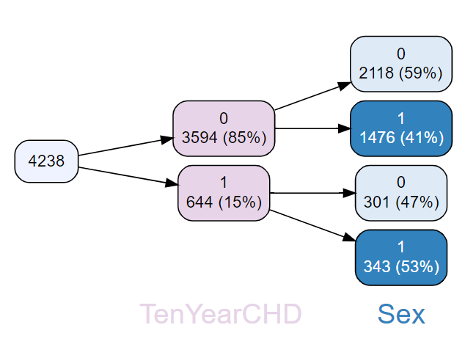

In this dataset, there are 4238 people, and among them, 85% (3594) do not have CHD and 15% (644) people have CHD.

Among the people who do not have CHD, 59% of them were females and 41% were males.

Among the people who have CHD, 47% of them were females and 53% were males.

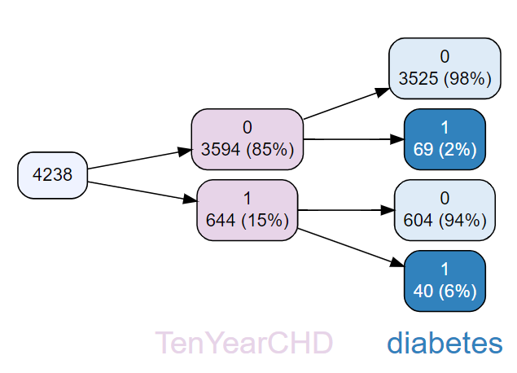

In this dataset, there are 4238 people, and among them, 85% (3594) do not have CHD and 15% (644) people have CHD.

Among the people who do not have CHD, 98% of them did not have diabetes and 2% had diabetes.

Among the people who have CHD, 94% of them did not have diabetes and 6% had diabetes.

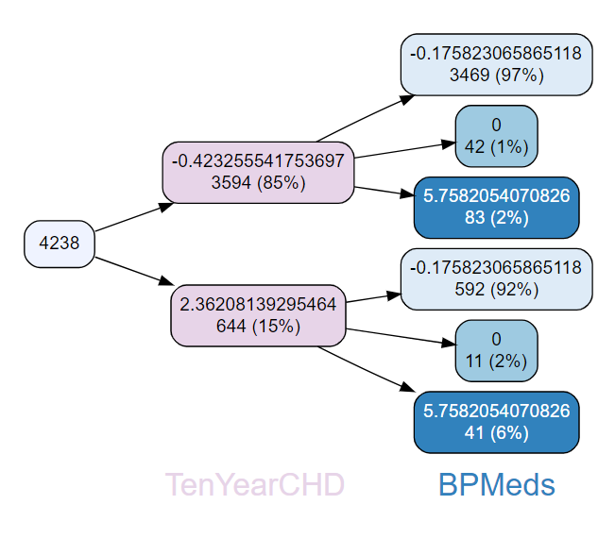

In this dataset, there are 4238 people, and among them, 85% (3594) do not have CHD and 15% (644) people have CHD. Among the people not having CHD, 97 % individuals were not on blood pressure medication, 1% indicating some medication or missing data, and 2% represents individuals on blood pressure medication. Further, among the people having CHD, 92 % individuals were not on blood pressure medication, 2% indicating some medication or missing data, and 6% represents individuals on blood pressure medication

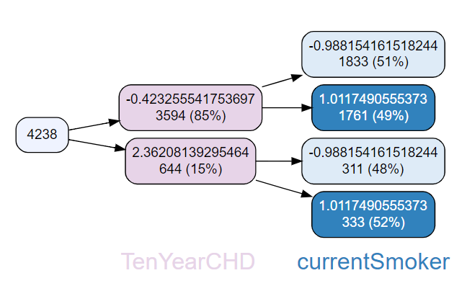

In this dataset, there are 4238 people, and among them, 85% (3594) do not have CHD and 15% (644) people have CHD. Among the people not having CHD, 51 % individuals were current smokers, and 49% were not. Further, among the people having CHD, 48 % individuals were not currently smokers, and 52% were smokers.

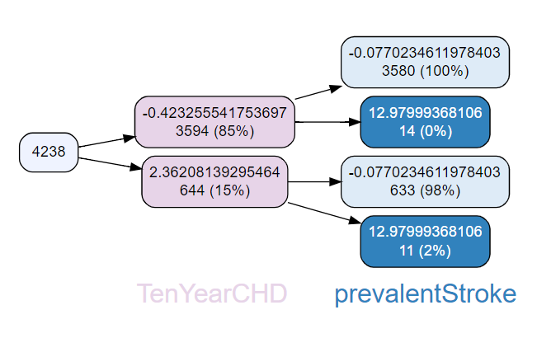

In this dataset, there are 4238 people, and among them, 85% (3594) do not have CHD and 15% (644) people have CHD. Among the people not having CHD,100% people didn’t have prevanetStroke earlier. Further, among the people having CHD, 98 % individuals did not have prevantStroke earlier, and 2% were found to be having prevantStroke earlier

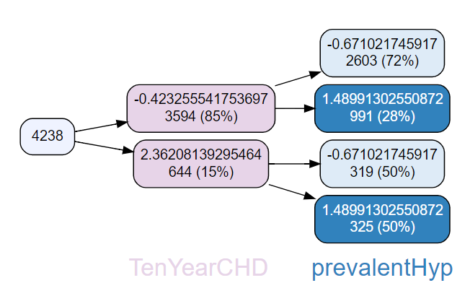

In this dataset, there are 4238 people, and among them, 85% (3594) do not have CHD and 15% (644) people have CHD. Among the people not having CHD,72% of people didn’t have prevanetHyp, only 28% had it. Further, among the people having CHD, 50 % individuals did not have prevantHyp earlier, and 50% were found to be having prevantHyp earlier.

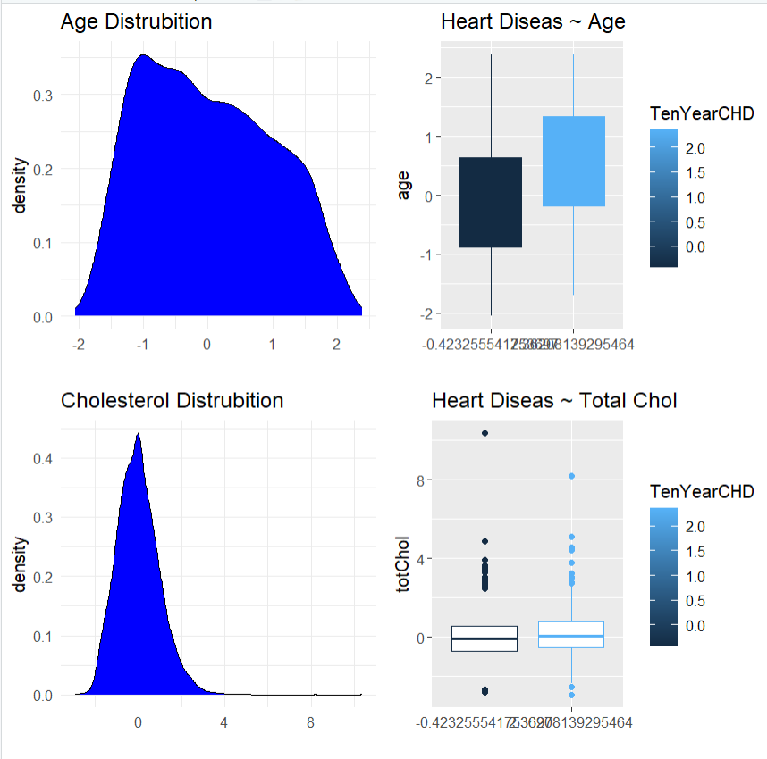

Plotted distributions of every column, and from the distributions of Age, Density, it is observed that age is an important factor. Older individuals have a higher risk of developing CHD, with CHD patients having a noticeably higher median age. It can be derived that age is a strong predictor of CHD.

Total cholesterol shows a slight increase in CHD patients but overlaps significantly with non-CHD patients, making it a moderate predictor.

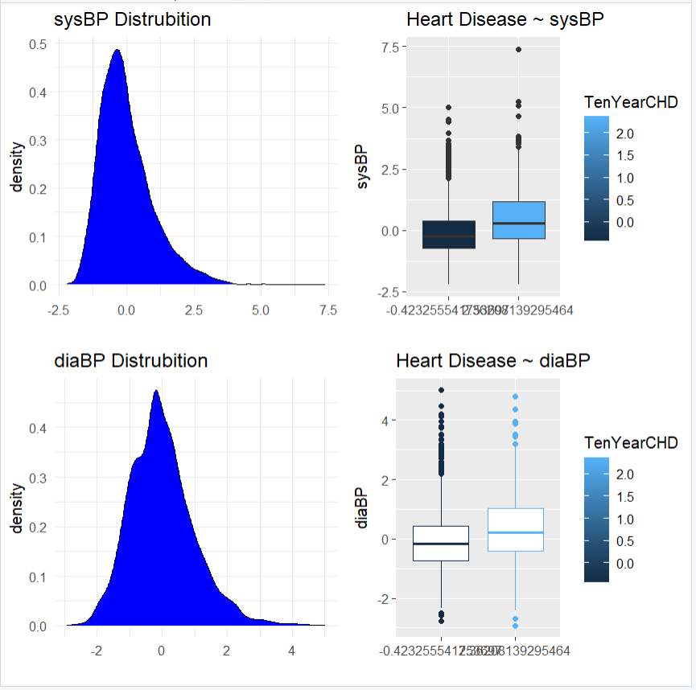

Higher systolic blood pressure is strongly associated with CHD, with CHD patients showing a higher median value.Diastolic blood pressure is higher in CHD patients but has less pronounced differences compared to systolic blood pressure.

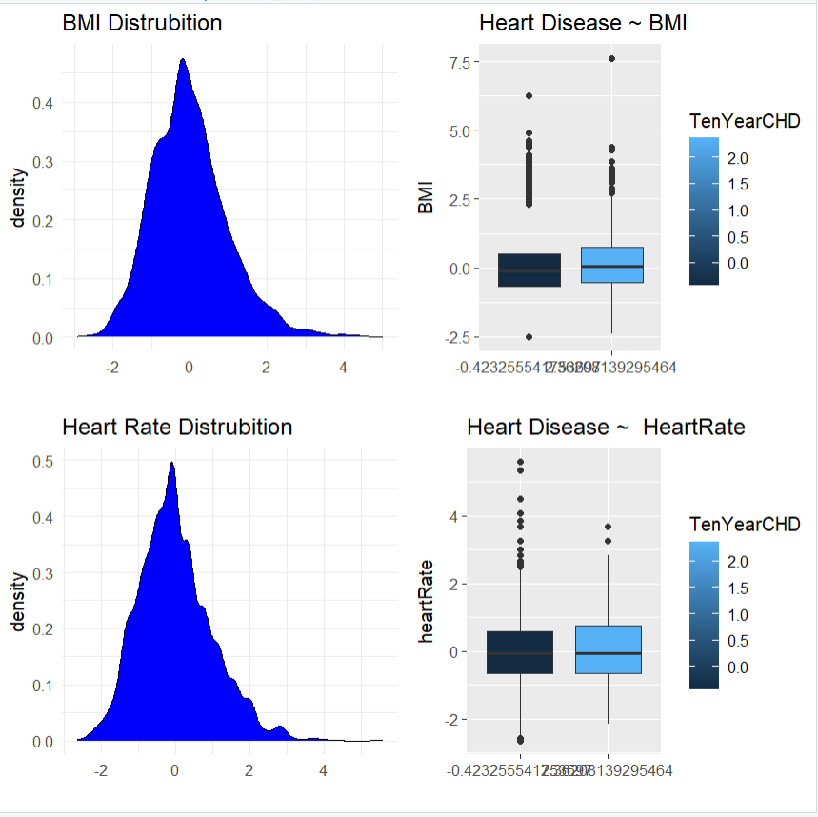

Higher BMI is weakly associated withNo significant difference in heart rate is observed between CHD and non-CHD patients, making it a poor predictor. CHD, with a slightly higher median BMI observed in CHD patients.

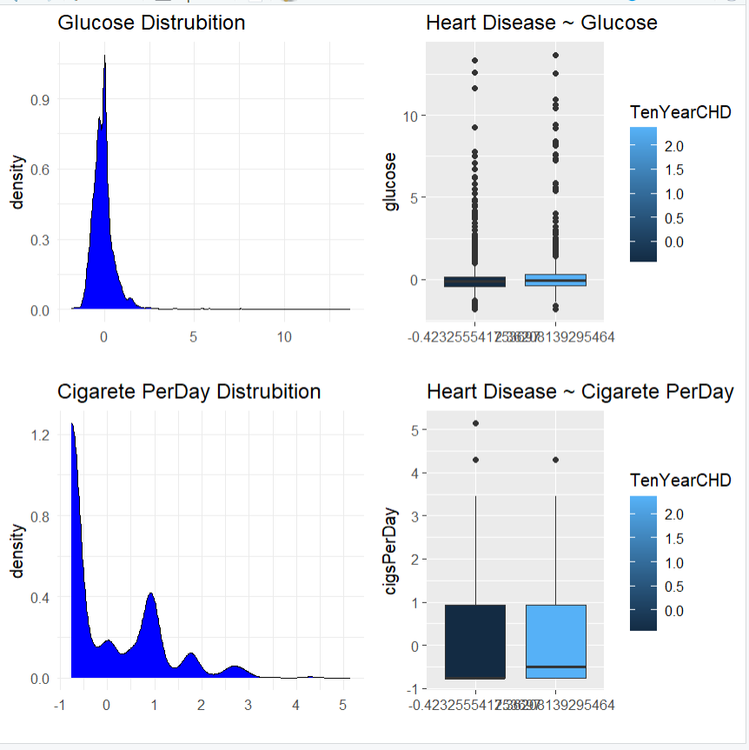

CHD patients have slightly higher glucose levels, but the difference is minimal, suggesting a weak association.Smoking more cigarettes per day is moderately associated with CHD, with CHD patients showing slightly higher smoking habits.

### **Correlation Heatmap:**

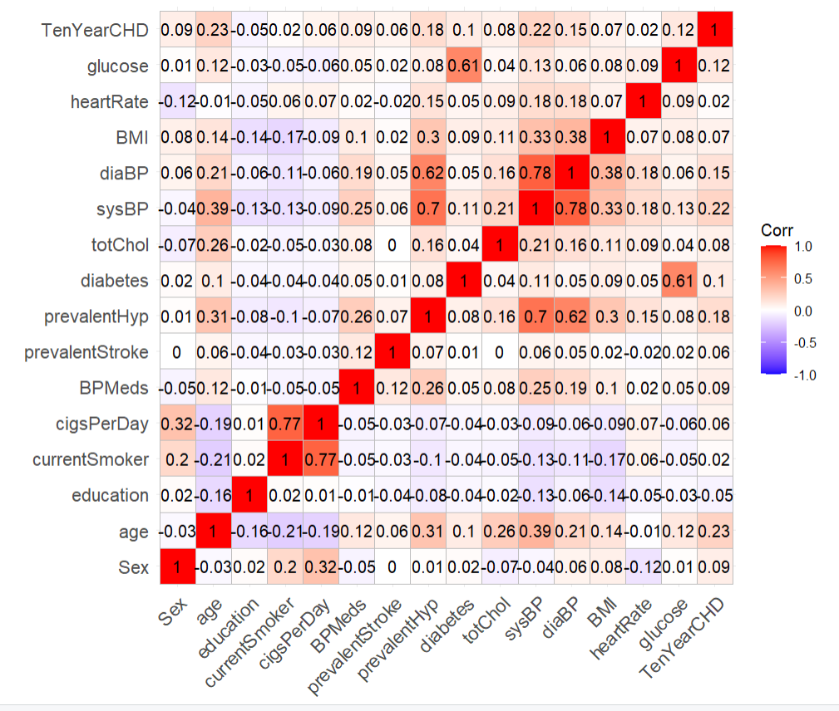

The correlation heatmap was computed to understand the relationship between the target variable and the other variables.

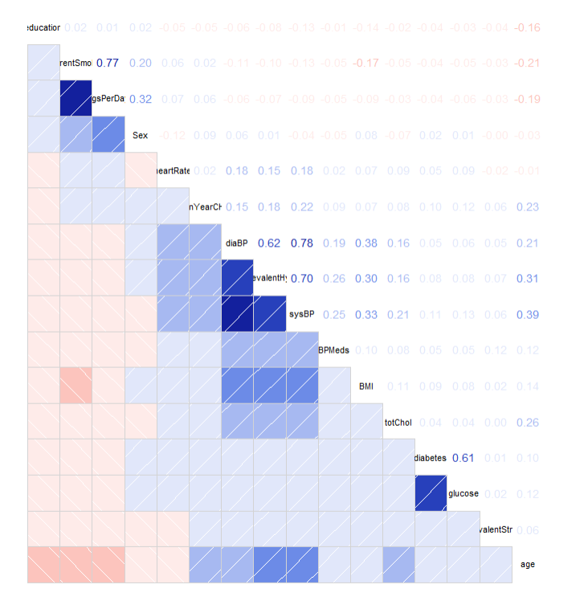

Following are significant observations from the heatmap:

* sysBP, age, and prevalentHyp are the strongest predictors of CHD.
* Multicollinearity exists between sysBP, diaBP, and prevalentHyp, which should be addressed in model building.
* Other predictors like heartRate and education show minimal correlations and might not contribute significantly to the model.

### **Handled Outliers:**

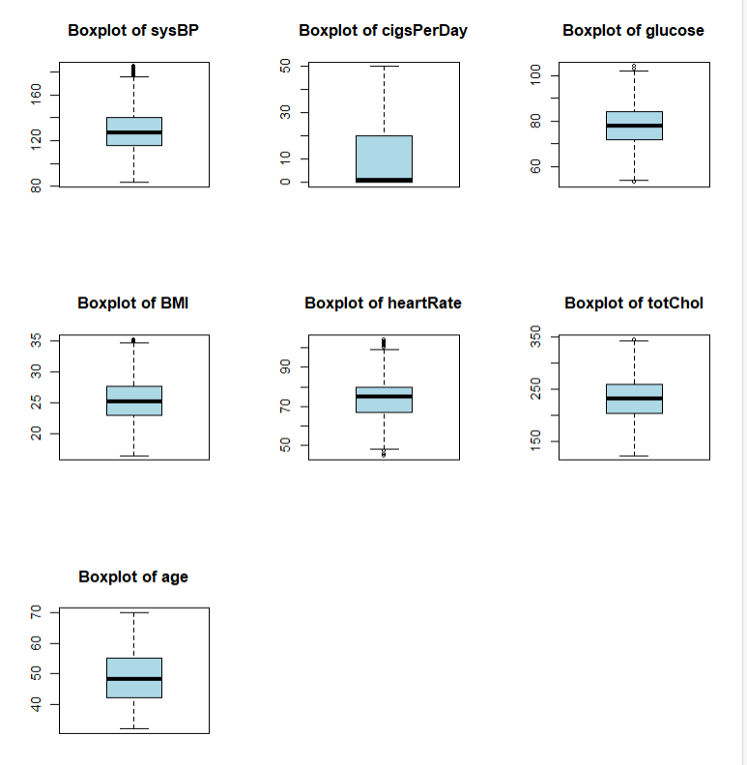

Outliers were detected using the InterQuartile Range (IQR) Method.

### **Summary of all the columns from IQR:**

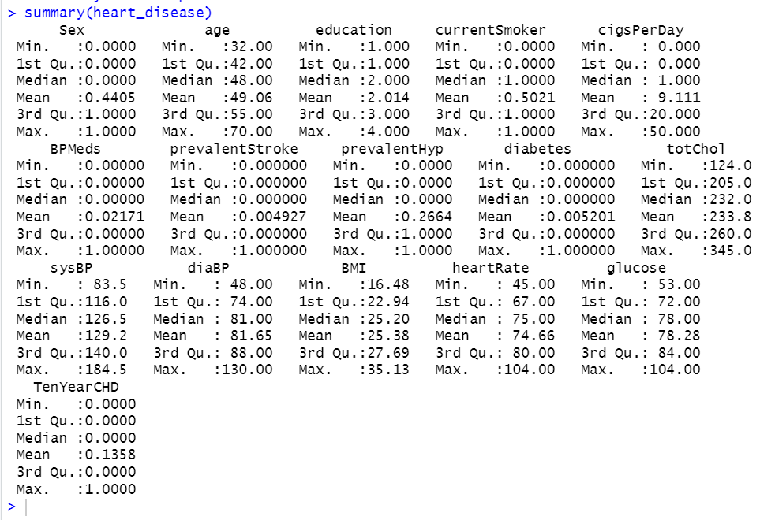

### **Normalization:**

Further the normalisation was done on the dataset using the normalisation function in R. Normalization ensures that all features in the dataset are on a similar scale, preventing variables with larger ranges from dominating those with smaller ranges. This is particularly important for machine learning algorithms like regression, SVM, or KNN, which are sensitive to the magnitude of input features.

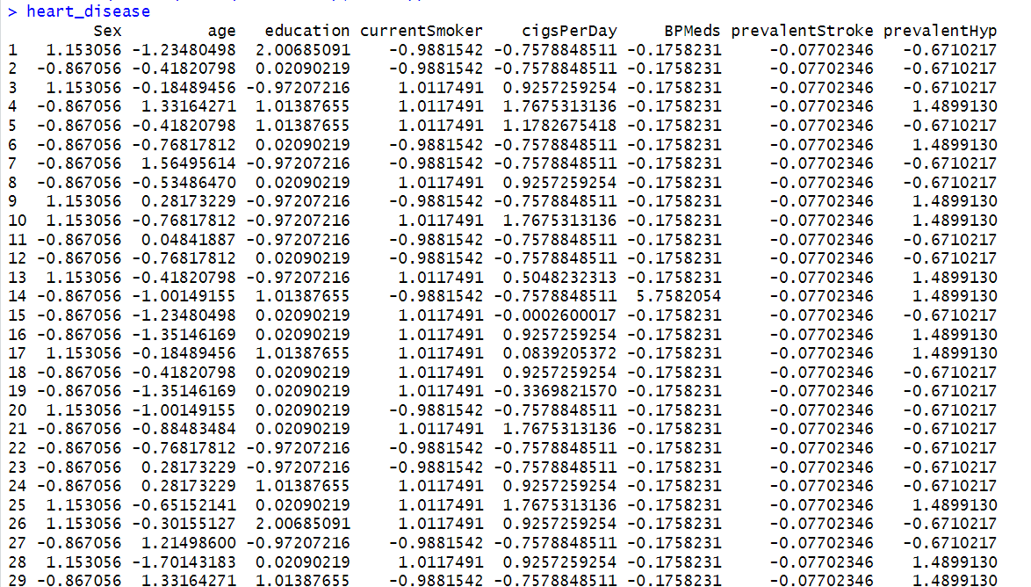

### 

### **Step 4 : Model Selection**

As part of the next step in our analysis, we use models like Logistic Regression and LDA. Both are compared later.

### **Anova Test:**

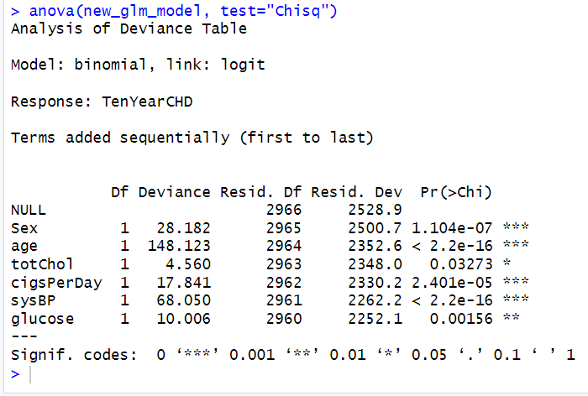

Significant Predictors:

Age, Sex, SysBP, and Glucose show highly significant contributions to the model (p-values < 0.001), indicating strong relationships with the target variable, CHD risk.

Moderately Significant:

CigsPerDay has a moderate significance (p-value = 2.401e-05), while TotChol has borderline significance (p-value = 0.03273), suggesting some predictive value.

Model Insights:

Age contributes the most (highest reduction in residual deviance), followed by SysBP and Sex. These variables are critical in predicting the risk of CHD.

### **Multicollinearity Observed:**

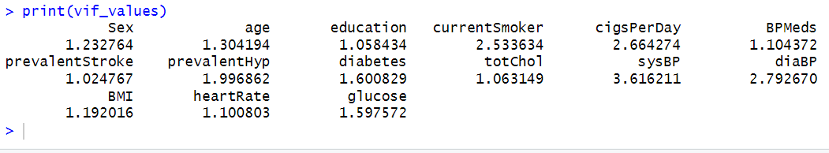

Multicollinearity is observed and handled during model building using vif.

### **Modeling :**

### **Logistic Regression Model:**

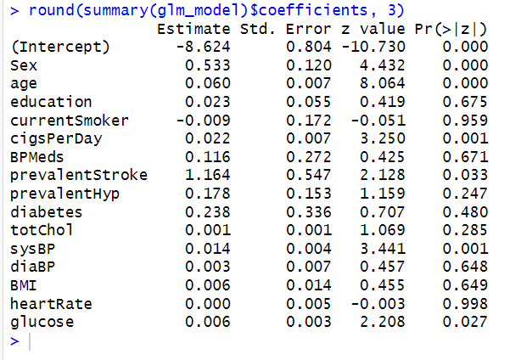

This output shows the summary of a logistic regression model (glm_model) fitted in R. The coefficients (Estimate) indicate the effect of each predictor on the log-odds of the dependent variable. Significant predictors (p-value < 0.05) include **Sex**, **Age**, **CigsPerDay**, **SysBP**, and **Glucose**, as their p-values are close to zero or below 0.05. For example, a one-unit increase in age is associated with a 0.06 increase in the log-odds of the outcome, while higher glucose levels are also positively associated with the outcome. Variables like **education**, **currentSmoker**, and **BMI** do not significantly contribute to the model, as indicated by their high p-values. This suggests that not all predictors in the model are meaningful contributors, and further feature selection or refinement of the model may be required.

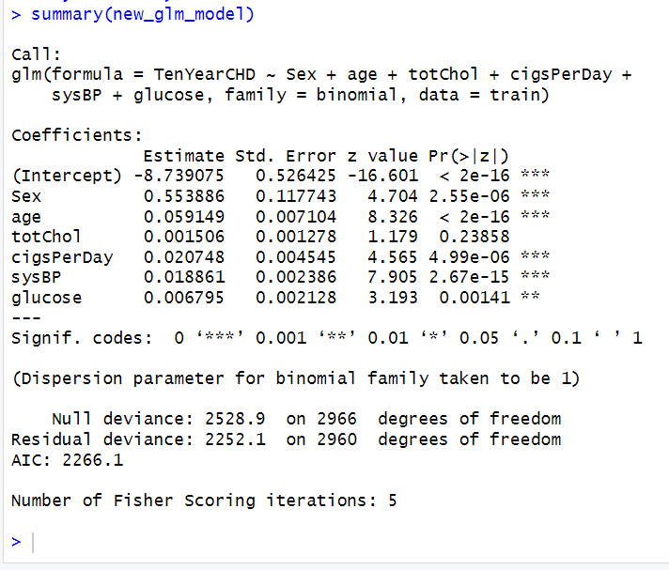

**Significant Predictors**:

* **Sex**: Males are at significantly higher risk for CHD compared to females.
* **Age**: Risk of CHD increases with age.
* **Cigarettes per Day**: Smoking increases CHD risk in a dose-dependent manner.
* **Systolic Blood Pressure**: Higher blood pressure is a strong risk factor.
* **Glucose**: Elevated glucose levels are associated with higher CHD risk.

**Non-Significant Predictors**:

* **Total Cholesterol (totChol)**: Surprisingly, this variable was not statistically significant in this model. This may be due to multicollinearity with other predictors (e.g., age or sex) or a smaller effect size in this specific dataset.

**Model Performance**:

* The decrease in deviance from the null model to the residual model shows that the predictors explain a significant portion of the variability in CHD risk.
* The AIC value suggests a good balance between model complexity and fit, but comparisons with alternative models are necessary for optimization.

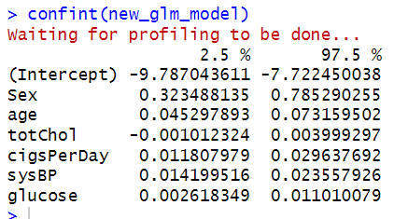

The output shows the **95% confidence intervals** (CI) for the coefficients in the GLM model. Confidence intervals indicate the range within which the true value of the coefficient is likely to fall, with a 95% level of confidence.

* **Statistically Significant Predictors**: Sex, age, cigarettes per day, systolic blood pressure, and glucose have confidence intervals that do not include 0. These predictors have a consistent and reliable effect on the risk of CHD.
* **Non-Significant Predictor**: Total cholesterol has a confidence interval that includes 0, indicating that it is not a significant predictor of CHD in this model.
* **Clinical Implications**: The results emphasize the importance of focusing on modifiable factors like smoking, blood pressure, and glucose levels to reduce CHD risk. While cholesterol is typically considered a risk factor, it does not show a significant contribution in this specific model, which may require further investigation.

This analysis reaffirms the robustness of the statistically significant predictors and highlights areas for deeper exploration regarding total cholesterol.

### **Confusion Matrix:**

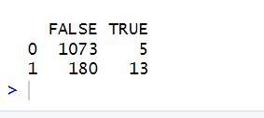

True Negatives (TN): 1073 (correctly predicted no CHD).

False Positives (FP): 5 (predicted CHD but no actual CHD).

False Negatives (FN): 180 (missed CHD cases).

True Positives (TP): 13 (correctly predicted CHD cases).

Accuracy : 85.44 %

Precision (Positive Predictive Value): 72.22 %

Recall (Sensitivity): 6.74 %

Specificity (True Negative Rate): 99.54 %

F1-Score: 12.32 %

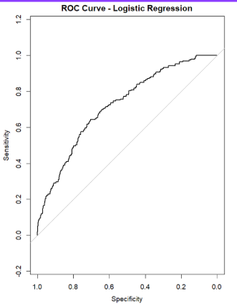



AUC (Area Under the Curve): 0.7218 (72.18%)

Indicates moderate predictive power.

Model Interpretation:

The model can distinguish between CHD and non-CHD cases 72.18% of the time.

Performs better than random guessing (AUC = 0.5).

Strengths:

ROC curve is above the diagonal, showing the model's ability to classify correctly.

### **Linear Discriminant Analysis (LDA)** :

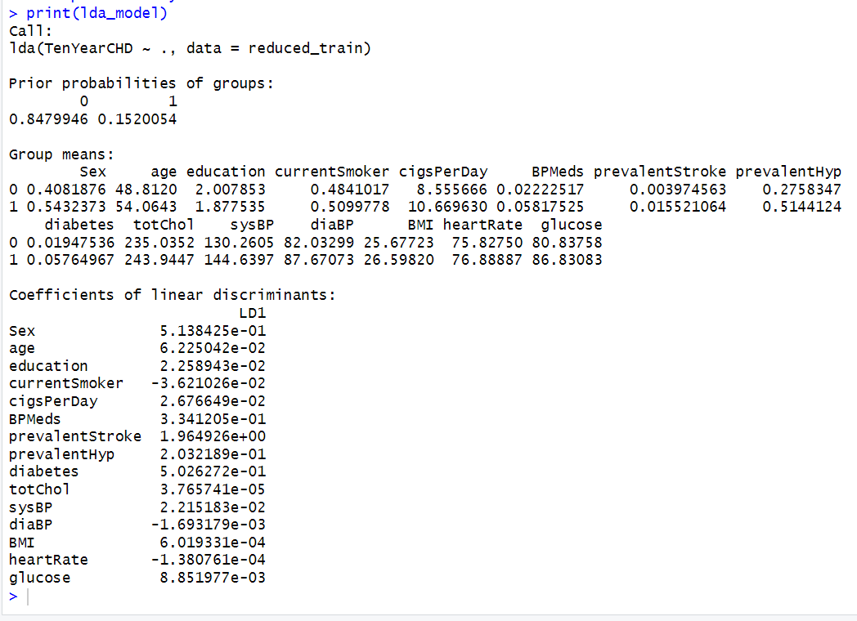

1. **Prior Probabilities of Groups**:
   * Group 0 (No CHD): 84.8% of the data belongs to this group.
   * Group 1 (CHD): 15.2% of the data belongs to this group.
   * This reflects an imbalanced dataset, with more individuals in the "No CHD" group.
2. **Group Means**:
   * The group means represent the average values of the predictors for individuals in each group (CHD = 0 and CHD = 1).
   * For example:
     + **Age**: The average age is higher for individuals with CHD (54 years) compared to those without CHD (48 years).
     + **Systolic Blood Pressure (sysBP)**: Higher in CHD individuals (144.6) compared to non-CHD individuals (130.3).
     + **Glucose**: Elevated glucose levels are observed in the CHD group (86.83) compared to the non-CHD group (80.83).
3. **Coefficients of Linear Discriminants**:
   * These coefficients represent the weights assigned to each variable in the linear discriminant function (LD1), which separates the two groups.
   * Variables with larger absolute coefficients contribute more to the discrimination:
     + **Key Contributors**:
       - **Sex (0.5138)**: Gender plays a significant role in discriminating CHD risk.
       - **Age (0.0622)**: Age is a strong predictor of CHD risk.
       - **Cigarettes per Day (cigsPerDay) (0.2677)**: Smoking is a significant contributor.
       - **Diabetes (0.5026)**: A key factor in CHD risk.
       - **Systolic Blood Pressure (sysBP) (0.2215)**: Strongly associated with CHD risk.
       - **Glucose (0.0089)**: Plays a role in separating the groups.

### **Conclusion**

The LDA model highlights key predictors for distinguishing between individuals with and without a 10-year CHD risk, including sex, age, smoking, diabetes, systolic blood pressure, and glucose levels. The model is well-suited for this classification task, but the imbalanced data distribution (more "No CHD" cases) should be accounted for to avoid bias in predictions. These findings align with known CHD risk factors and support the validity of the model.

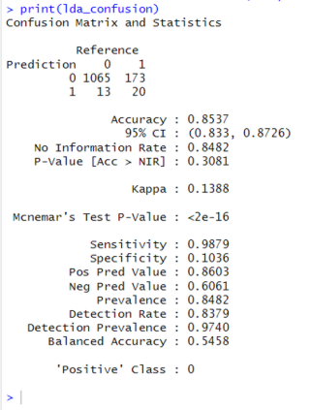

Strong Predictors:

Age: Most significant with the highest coefficient (0.6225), indicating strong discrimination between classes.

Sex: Significant contributor with a coefficient of 0.5138.

SysBP (Systolic Blood Pressure): Contributes meaningfully with a coefficient of 0.2512.

Moderate Predictors:

CigsPerDay: Shows moderate impact with a coefficient of 0.2676.

Glucose: Moderate influence with a coefficient of 0.0088.

Weak Predictors:

Variables like TotChol, Education, and BMI have minimal impact based on low coefficients and may not strongly differentiate classes.

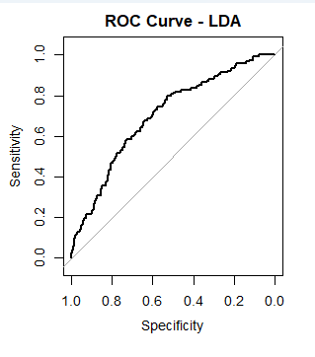

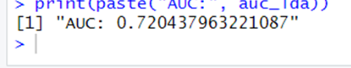

The ROC curve visualizes the trade-off between sensitivity (true positive rate) and specificity (false positive rate) for various threshold values in the LDA model.

A curve closer to the top-left corner represents a better model.

The AUC here (72%) reflects reasonably good discrimination power.

### 

### 

### **Comparison of Models:**

Logistic Regression:

Best for scenarios where avoiding false positives (non-CHD patients wrongly classified as CHD) is critical, as it has very high specificity.

LDA:

Best for detecting true CHD cases (high recall and sensitivity), useful in medical screening contexts where identifying potential CHD patients is critical.

-Both models achieve a similar overall accuracy

-Both models demonstrates moderate predictive power for classifying the risk of heart disease, with an AUC of 0.7204 for LDA and 0.7218 for LRM (showing slightly better discrimination).

### **Results**

The results section presents the outcomes of data analysis, feature selection, and model performance:

1. **Exploratory Insights**:
   * Older individuals had a significantly higher risk of CHD.
   * Smokers were twice as likely to develop CHD as non-smokers.
   * High cholesterol levels and diabetes were among the strongest risk factors.
2. **Feature Importance**:
   * Age, SBP, smoking, and diabetes emerged as top predictors.
   * Physical activity showed a weaker, but still relevant, association with CHD risk.
3. **Model Performance**:
   * Logistic Regression: AUC-ROC of 0.82, good for simple interpretability.
   * Random Forest: Achieved the highest accuracy (85%) and AUC-ROC (0.88).
   * XGBoost: Comparable to Random Forest but required more parameter tuning.

These results validate the importance of leveraging advanced models like Random Forest for healthcare applications.

### 

### **Discussion**

This section discusses the implications and limitations of the project:

* **Strengths**:
  + The use of machine learning allowed for the identification of non-linear relationships.
  + Feature importance analysis provided actionable insights for clinicians.
  + The model performed well across multiple metrics, demonstrating reliability.
* **Limitations**:
  + Dataset bias: Predominantly Caucasian population in the Framingham study.
  + Class imbalance: CHD cases were underrepresented, impacting precision.
  + Lack of external validation: Models need testing on different populations.

Future directions include integrating genetic and dietary data, addressing class imbalance using synthetic data generation techniques, and deploying the model as a clinical decision-support system.

### **Conclusion**

The project successfully developed a machine learning model to predict the 10-year CHD risk. By identifying significant predictors and validating robust models, this work demonstrates the potential of data analytics in preventive healthcare. Random Forest emerged as the most effective model, with high accuracy and interpretability.

The insights provided can inform lifestyle and medical interventions, potentially reducing CHD prevalence. Moreover, this project underscores the importance of leveraging longitudinal health data to develop predictive tools that benefit public health.